A regular manifold is:[An Introduction to Manifolds by Loring T Wu]

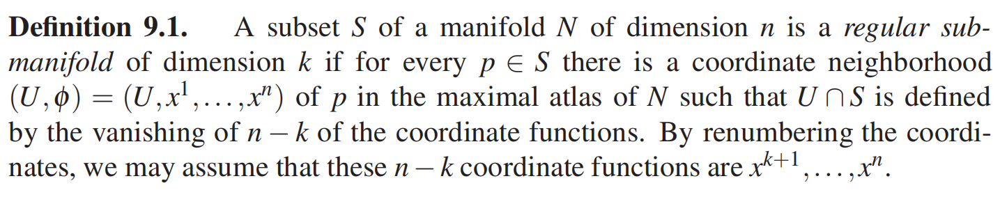

There are many examples such as:

1. x^3+y^3+z^3=1



1. x^2+y^2+z^2=1

